2022 PONY EXPRESS HORSE SHOW CIRCUIT - NOMINATION FORM
• • • • ONE HORSE/RIDER “PER FORM” - USE ADDITIONAL FORMS IF NEEDED • • • •
I wish to nominate Horse/Rider for them to be eligible for Pony Express Horse Show Circuit Awards.
I understand that the following criteria must be met for my points to count:
HORSE OWNER MUST BE A MEMBER & EACH RIDER OF THE NOMINATED HORSE MUST BE A MEMBER
Copies of Amateur Cards, and Registration Papers, must accompany this form where applicable.
If a change occurs at any time, I will notify the Point Recorder immediately.
NO REFUNDS
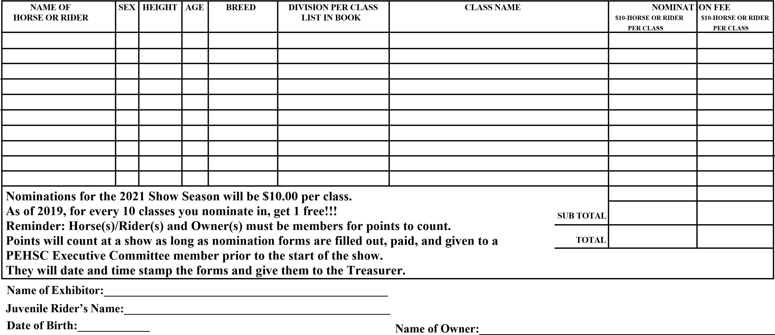Stable Affiliation:_________________________________________________
Make Checks or Money order payable to: PEHSC  Return to: Dori Walker  15411 N Eastern  Smithville, MO 64089 760-855-9285 dori@doriwalker.com | Street Address____________________________________________________  City, State, Zip:__________________________________________________  Phone:___________________________________________________________ Email:___________________________________________________________  Date:___________________________________________________________

